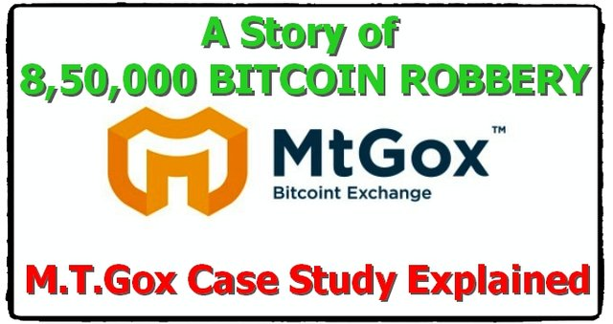

Today we talk about the first & most bitcoin hacked story in the crypto industry. To know about this hack we have to go to the year 2013. Mark Karpeles is one of the most imp people in the crypto industry because he is the owner of the Japan's most famous crypto exchange MT. Gox (Magic The Gathering Online Exchange).



It was the world’s big exchange in crypto exchange at least world’s 72 % transactions are working on this exchange on daily basis. The company is as it’s top move & everything is going very fine, but one of the Tokyo’s software engineer went to MT. GOX office for his job & there he saw something wrong in this exchange which became the MT. Gox’s bad night.

**Problems with MT.Gox.**

The main problem is Lack of VCS means { Version Control Software }. Every software company has its VCS. It is important because every exchange has a website which has a CODE BASE where all coding is done or reshuffled for updated version &these s changes are saved in VCS. VCS watches every moment in the code changing & told you who change the codes at which time & also provide the reverse option but this feature is not available at MT.GOX.

Unavailability of VCS becomes the worst & disastrous situation in MT. GOX. This is why any programmer can changes MT. GOX Codes without there permission & they will never find out who changes there codes & at which time. This is the most valuable mistake was done by MT. GOX

The Testing Policy :- This is MT.GOX’s second mistake. They never get testing policy seriously. They made programme test usually & give it to users. Just think, world most valuable exchange and there is no proper testing policy. This is the second most reason for the hack of MT. Gox.

Lack of Proper Management :- This is the third problem in MT.GOX. Exchange. For any exchange, management is very important Karpeles do coding very well but in management, he fails. This all thing are moving towards the disaster of MT.GOX Exchange

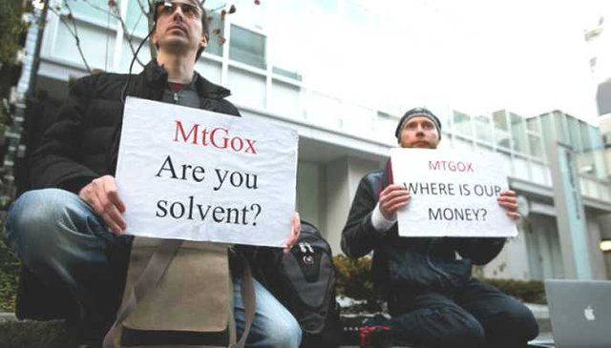

**19th JUNE 2011**

On this day Btc value in MT.GOX appeared & shown 1 cent per Bitcoin. But what happen how Bitcoin’s price touches this low price. Actually, on this day the M.T.Gox computer was hacked and large amout of coins are transferred and exchange is going on MT. GOX’s Exchange only. Any hacker when hack coins or transferred to any account he has to sell it as quickly so he sells such coins at the lower rates as soon as possible. On that time Bitcoin’s Price is 400 $ & hackers sold hacked coins for 300 $ per bitcoin’s price. In this way, the hacker sells his coins & left the exchange. If a hacker does not withdraw earlier then exchange can catch this activity and banned the account. In this case, the hacker slowly sells his coins and left the exchange. Afterwards MT. Gox team settle down this whole thing but this was too late. Already $ 87,50,000 was gone from this exchange

**Year 2014**

Suddenly transaction are going slow & delayed in MT. GOX exchange. Users filed a large number of complaints against MT. GOX. Hence they stopped all the transactions of Bitcoin. On 1st February , 2014 they send the mails to customers that they will require more time to solve the issue & after proper check, they will start exchange before 10th February, 2014 . After the deep thinking, they see that they are being the victim of transaction malleability attack.

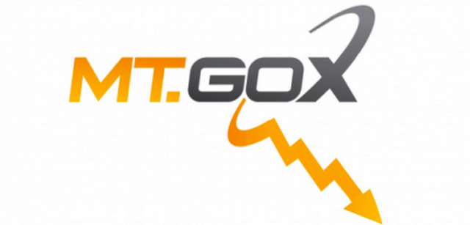

**TRANSACTION MALLEABILITY ATTACK ?**

As we know that in Bitcoin’s transaction we can’t reverse the transaction once done. This special quality of Bitcoin becomes someone Profit & Someone Loss. Now we take a example on normal Bitcoin Transaction suppose DASHRATH send some amount of Bitcoins to GAUTAM the DASHRATH first click on the address of the Gautam Miner confirms this transaction & went to Gautam. What will happen if the details of the address changed before Dashrath click on the address button. This exactly happened on this time in MT. GOX Exchange. Customer request for withdrawal MT. GOX process the transaction and in between hacker changed the receives address. Then customer’s keep on complaining to exchange again & again that the payment not received. Then again MT.GOX stopped all transaction, withdrawal & deposits. Hence this way World’s most popular and Biggest Exchange MT. GOX hacked and bankrupt .

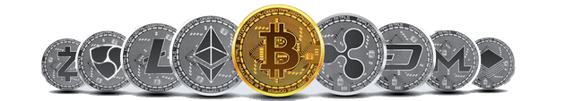

After all this things, BITCOIN still move ahead and more strongly build its community in the world.

